Tile Minimization Problem

The Wang tiling problem is a problem in discrete dynamics that asks if a set of square tiles with colored edges can tile the plane. A Wang Tile is a square with four (north, south, east west) edges along its borders, each with a specific color. A set of Wang Tiles form an instance of The Tiling Problem. The Tiling Problem asks, given a set of Wang Tiles, is it possible to tile the integer two-dimensional plane where adjacent tiles (either horizontally or vertically) have matching colored edges? The tiling problem can also be framed in terms of arbitrary finite rectangles rather than an infinite plane --- whether or not for any arbitrary $n×m$ space, the tiles can tile that space.
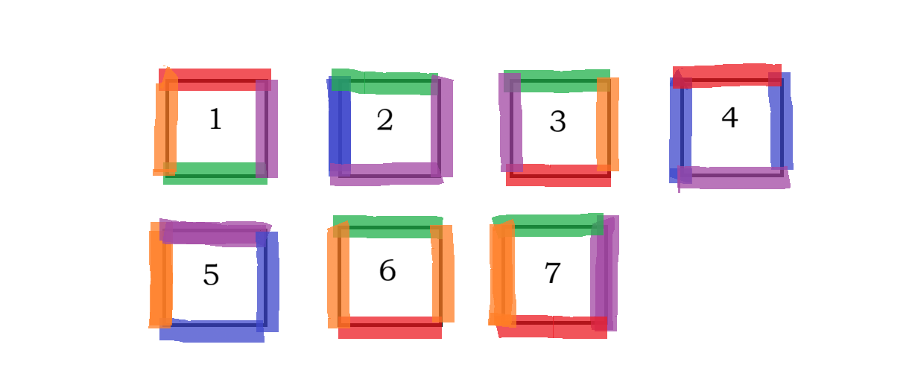
Figure 1: 7 Wang Tiles with Colored Edges, and labelled numbers (this is an example of an unsatisfiable set).
Hao Wang conjectured the tiling problem was solvable. Robert Berger (1964, Harvard) constructed a tile set with over ~20k tiles to show Wang that his conjecture was wrong, also showing the tiling problem is undecidable.
Wang Tiles were particularly of interest in relation to Entscheidungsproblem, which asks whether a first order sentence is valid (or the opposite question, whether it is satisfiable). The concept was used to show that a very narrowly tailored subclass of first order sentences --- one of the form $∀x∃y∀z P(x,y,z)$ where x,y,z are bounded variables, P is a quantifier-free formula, and P consists of only binary predicates --- was undecidable. Actually, Wang and other mathematicians in 1962 showed that the Tiling Problem with a restricted diagonal constraint relative to an origin --- was unsolvable. The full unrestricted generic version was shown to be undecidable 4 years later.

A subshift of finite type consists of a nonempty finite set A, called an alphabet, a d-dimensional space $Z^{d}$ (or lattice, or plane), and a finite set F of strings (or finite tuples of A --- relative to a specific dimension), called forbidden factors. The subshift is a function $λ :Z^{d}→A$ such that for any consecutive run of coordinates in any one dimension, i.e. ($x_{0},x_{1},…x_{k},…x_{d+1}$), that tuple does not belong to A. Subshifts of finite type are shift invariant which means local positions and offsets do not affect the dynamics or structure of the mapping $λ$ (consequently, the origin cannot be restricted to a certain character in A). A corresponding decision problem is whether or not such a mapping $λ$ exists, that satisfies the forbidden factor constraints. If such a mapping $λ$ exists, the subshift of finite type $\left(A,F\right)$ is said to be satisfiable, otherwise it is unsatisfiable.
Wang Tiles reflect the problem of whether or not $λ$ exists for dimension $d=2$.
When working with Wang Tiles, such as with Figure 1 for example, for the purposes of this paper, it is better to interpret them as a subshift of finite type rather than as a set of tiles with colored edges. In that case, the constraints are determined by a forbidden factor set (horizontally and vertically) of two tuples or ordered pairs. The reason will become evident later.
For example, in Figure 1, there are seven square tiles with colored edges where adjacency constraints are determined by matching edge colors (i.e. red, green, blue, orange, or purple edges next to each other). To interpret this as a subshift of finite type constraint problem, one enumerates tiles that can be adjacent horizontally and vertically, then drops the colored edge constraints. For a subshift of finite type over the alphabet A = {1,2,3,4,5,6,7}, Figure 1 can be translated into an equivalent forbidden factor list, where H is the set of all horizontal forbidden constraints, and V is the set of all vertical forbidden constraints
$$F=\{H,V\}$$
$$H^{c}=\left\{\left(1,3\right),\left(2,3\right),\left(3,5\right),\left(3,6\right),\left(3,7\right),\left(4,2\right),\left(5,2\right),\left(5,4\right),\left(6,1\right),\left(6,5\right),\left(6,7\right),(7,3)\right\}$$
$$V^{c}=\left\{\left(1,2\right),\left(1,3\right),\left(1,6\right),\left(1,7\right),\left(2,5\right),\left(3,1\right),\left(3,4\right),\left(4,5\right),\left(6,1\right),\left(6,4\right),\left(7,1\right),(7,4)\right\}$$
(Note that ^c denotes complement and $H∪H^{C}=A^{2}$, and $V∪V^{C}=A^{2}$)
We will actually want to specify the complement of these sets, since often is the case, many interesting Wang Tile sets are very restrictive, so naturally the complement (that is, the allowed factors) is much more compact to write.
The main problem then, for this paper, will be stated in terms of allowed patterns.
Question:
Let $A$ be an alphabet and let $a,b∈A$ be two characters in $A$. Consider the set $A^{'}=\left(A \backslash \left\{a,b\right\}\right)∪\left\{c\right\}$, given by replacing both characters a and b with a single common character c, and the modified factor set for H and V as: ${H^{C}}^{'} :\left\{\left(x,y\right)∈H :\left(x≠a\right)∧\left(x≠b\right)\right\}∪\{\left(x,c\right) :x∈H, c=a∨b\}∪\{\left(c,x\right) :x∈H, c=a∨b\}$ and similarly ${V^{C}}^{'} :\left\{\left(x,y\right)∈V :\left(x≠a\right)∧\left(x≠b\right)\right\}∪\{\left(x,c\right) :x∈V, c=a∨b\}∪\{\left(c,x\right) :x∈V, c=a∨b\}$. Let $F'=H^{'}∪V^{'}$. The question on hand is whether or not $(A,F)$ is equisatisfiable to $\left(A',F'\right)$, in the sense of showing that $(A',F')$ does not produce additional solutions that cannot be mapped back to a solution in $(A,F)$.
The latter clarification can be expressed in terms of local and extraneous solutions:
A local solution, in this context, for some arbitrary character $a∈A$ (subshift of finite type) is a tuple $(a_{1},a_{2},a_{3},a_{4})∈A$, where a solution $λ⊆A^{Z^{2}}$, exists for integers $x,y$ such that $λ\left(x,y\right)=a$, $λ\left(x-1,y\right)=a_{1}$, $λ\left(x+1,y\right)=a_{2}$, $λ\left(x,y-1\right)=a_{3}$, $λ\left(x,y+1\right)=a_{4}$.
An extraneous solution, in the context of definition of $A^{'}$ (modified subshift of finite type), and common character $c∈A$, is a local solution $\left(c_{1},c_{2},c_{3},c_{4}\right)∈A$, where there is at least two characters $u,v∈\left\{c_{1},c_{2},c_{3},c_{4}\right\}$ such that $\left(a,u\right),$or $\left(u,a\right)$, (horizontally or vertically) is an allowed factor in the subshift ($A,F$), while that same tuple $\left(b,u\right),$or $\left(u,b\right)$, (horizontally or vertically) is a forbidden factor in the subshift $(A,F$). Along with the definition of, similarly one of $\left(b,v\right),$or $\left(v,b\right)$, (horizontally or vertically) is an allowed factor in the subshift ($A,F$), while that same tuple $\left(a,v\right),$or $\left(v,a\right)$, (horizontally or vertically) is a forbidden factor in the subshift $(A,F$). Both characters $a,b$ in the original subshift are replaced with a new shared character $c$, in the modified subshift, and extraneous solutions are solutions that if $c$ was reverted to either $a$ or $b$ --- those solutions cease to exist in $(A,F)$.
The problem is then whether for an arbitrary subshift $(A,F)$, and two characters $a,b∈A$, if the modified subshift $\left(A^{'},F^{'}\right)$ by replacing all instances of $a,b$ with $c$, admits any extraneous solutions. If the answer is no, then the characters $a,b$ are said to be mergeable (and thus both subshifts are said to be equisatisfiable). If the answer is yes (extraneous solutions exist), then the characters $a,b$ are said to be non-mergeable.
In general, this problem is semi-decidable (but not decidable):
For an arbitrary subshift $(A,F)$, and two characters $a,b∈A$, if those characters are mergeable, there exists a positive integer $k$, such that for a finite plane (or square) of dimension $\left(2k+1\right)×\left(2k+1\right)$, for the subshift of finite type $(A^{'},F')$ and the character $c$ is in the center of that square, there is no satisfiable partial mapping $λ⊆A^{P^{2}}$, where $P=\{\left(x,y\right):-k≤x,y≤k\}$, which satisfies the forbidden factor constraints.
This also directly translates to an NP complete problem in terms of $k$ (the problem of determining whether or not a set of Wang tiles can tile a rectangle of size $n×m$ is NP-complete).
However, if an extraneous solution does exist, a search for such $k$ will never yield anything, and such solutions may have to be shown using different methods if possible.

